Sprint 4 Plan

Plan-it

Team Rocket

12/1/2019

Revision 1, 11/18/2019

<https://app.clubhouse.io/teamrock/epic/37/plan-it?label_ids=105>

High level goal: *Allow users to provide feedback, and save their favorite plans*

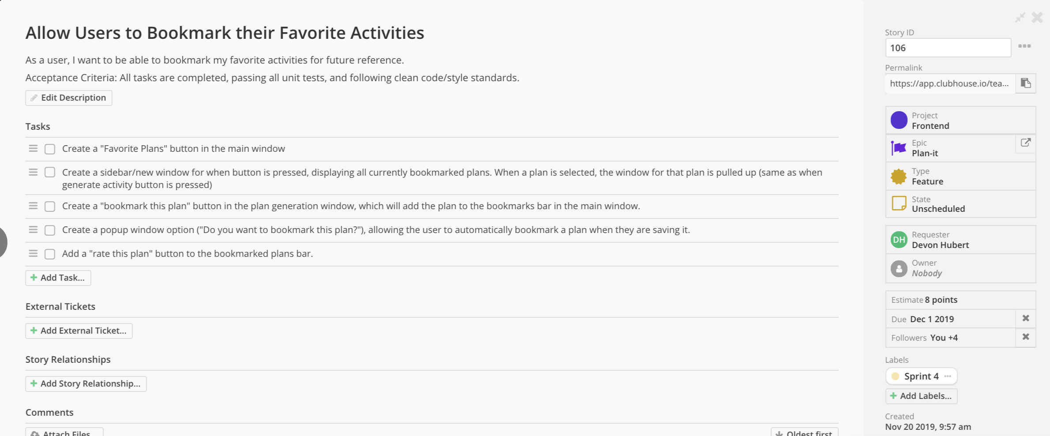

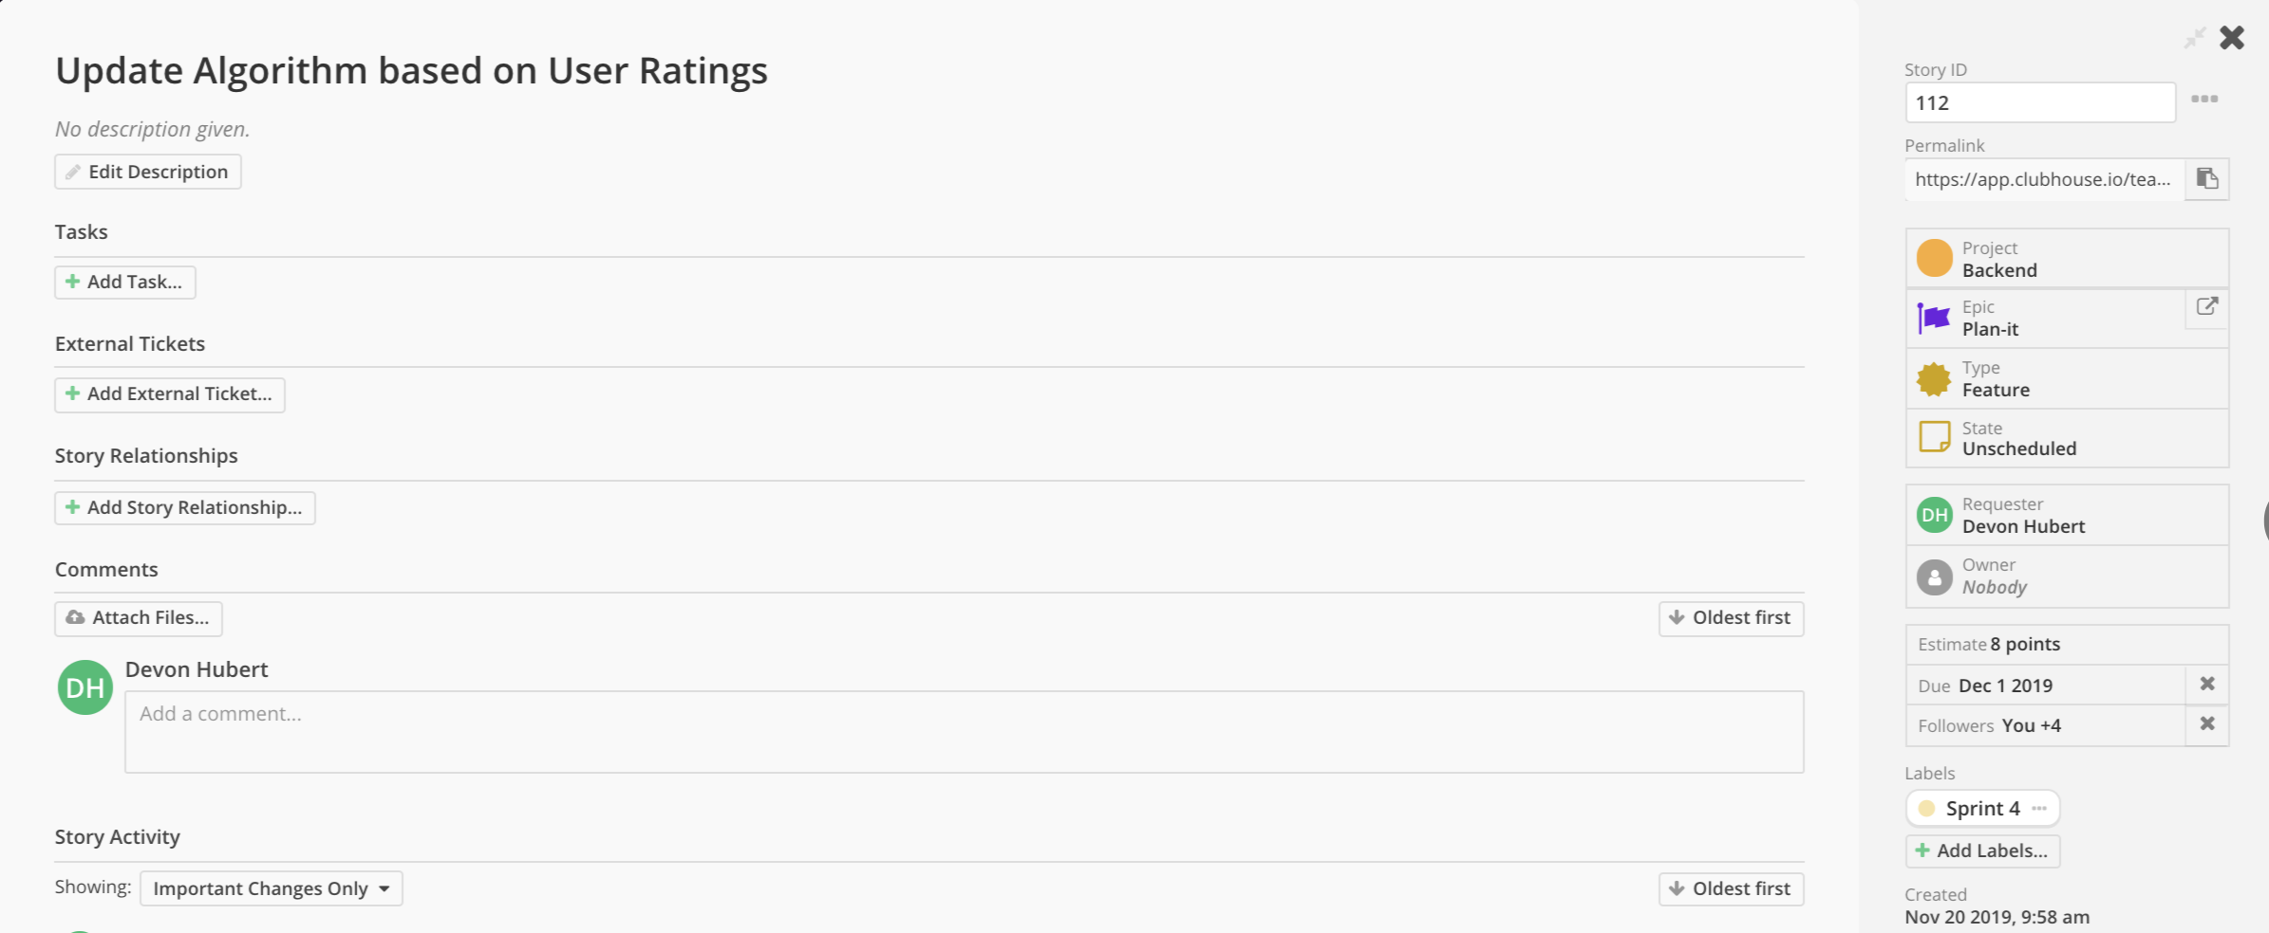

Meeting times: Monday, Wednesday, and Friday at 11:30. TA meeting on Wednesdays at 10:30 in room 316.